**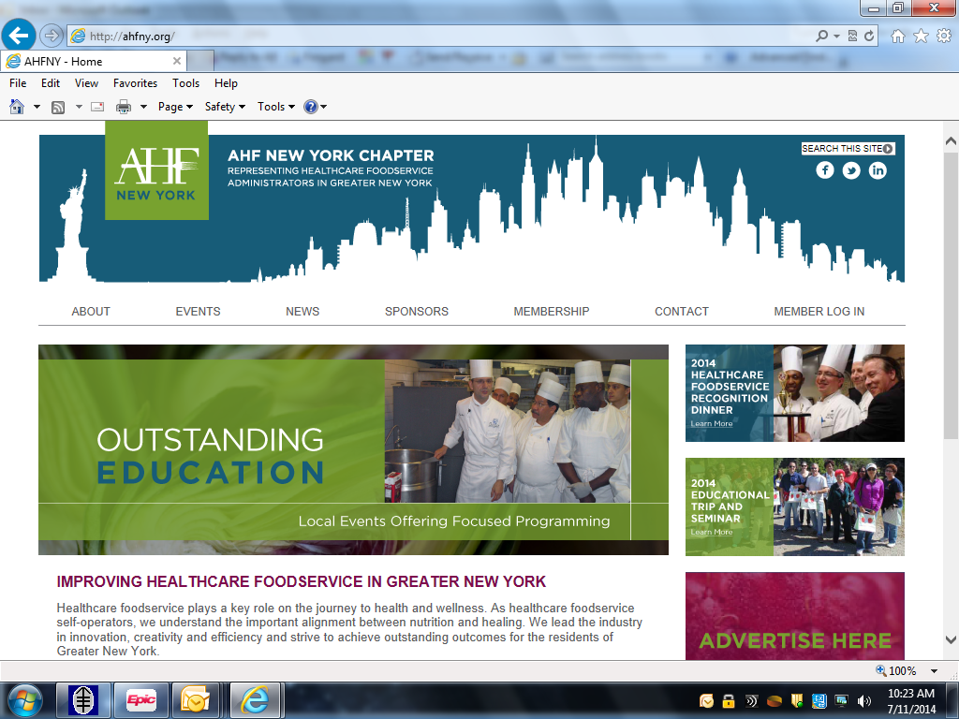**

**Updated 3/22/2023 CALENDAR** [**WWW.AHFNY.ORG**](http://www.ahfny.org)

|  |  |  |
| --- | --- | --- |
| **January**  **TBD** | **Community Volunteering Event** |  |
| **February 22**  **3-4PM** | **How Female African American Chef**  **have helped with Mental Health Webinar**  **Sponsored by: AHFNY**  **1 CEU for RD & CDM** | **Speaker: Charles L. Smith Executive Chef**  **VISN2 South Commissary**  **Moderator: Stephen Chow**  **Free to members** |
| **March 15**  **2:30-3:30PM** | **Joint Commission Preparedness Webinar**  **Sponsored by: AHFNY**  **1 CEU for RD & CDM** | **Speakers: Lisa Yeung, MS, RDN, CDN, Director & Barbara Jordan, MS, RDN CDN, Clinical Nutrition Manager, Memorial Sloan Kettering**  **Cancer Center**  **Free to members** |
| **April 21**  **5-8PM** | **C:\Users\mclymonv\AppData\Local\Microsoft\Windows\Temporary Internet Files\Content.Outlook\WH5KGA76\logo_ice.jpg**  **“Using Spices to Flavor Food”**  **Ori Zohar**  **Co-sponsored by: AHFNY & US Foods**  **3 CEU for RD & CDM** | **INSTITUTE OF CULINARY EDUCATION**  **225 LIBERTY ST**  **NEW YORK, NEW YORK**  **Free to members & friends** |
| **May 11**  **3-4PM** | **Ethics in Clinical Nutrition Leadership Webinar**  **Sponsored by: AHFNY**  **1 CEU for RD & CDM** | **Speaker: Kareen Turner, MPH,**  **RDN CHPC**  **Free to members** |
| **June 9**  **8-4PM** | **Annual Symposium**  **“New Horizons in Health Care Food Service”**  **6.5 CEU for RD & CDM** | **SHERATON LAGUARDIA**  **EAST HOTEL**  **135-20 39TH AVENUE**  **FLUSHING, NY 11354** |
| **July 20**  corn crop and iowa farm at harvest time - farm stock pictures, royalty-free photos & images | **Wine & Equipment Education Tour**  **Sponsored by: AHFNY**  **4 CEU for RDN & CDM** | **VA St. Albans CLC Parking Lot Leaving 8AM Sharp**  **Space is limited (no refund)**  **Registration will follow** |
| **August 8-11** | **AHF Annual Conference** | **Orlando, Florida** |
| **October-20** | **Culinary Institute of America**  **Educational Tour including Lunch**  **Co-sponsored by: AHFNY and PBAC**  **4 CEU for RD & CDM** | **VA St. Albans CLC Parking Lot**  **Leaving 8AM Sharp**  **Space is limited (no refund)**  **Registration will follow** |
| **November-TBD** | **Community Volunteering Event** |  |
| **December 6**  **6:30-10:30PM** | **Holiday Party - Employee Recognition &**  **Officer Installation**  [http://www.planwallpaper.com/static/images/christmas.jpg](http://www.google.com/url?sa=i&rct=j&q=&esrc=s&frm=1&source=images&cd=&cad=rja&uact=8&ved=0ahUKEwiVtqqJksDJAhWE7yYKHU7MAuYQjRwIBw&url=http://www.planwallpaper.com/images-christmas&psig=AFQjCNFMkvKfSZ-IveKQcO7OUT3FDRkn3A&ust=1449247566407328)**Sponsored by: AHFNY** | **RUSSO’S ON THE BAY**  **162-45 CROSS BAY BLVD.**  **HOWARD BEACH, NY 11414** |